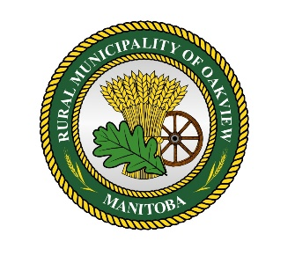
R.M. of Oakview
Public Notice: COVID-19

The RM of Oakview is closely monitoring the COVID-19 situation and encourages all ratepayers to follow the recommendations of our Province and Federal governments to contain the virus:
- Social distancing
-Avoid greetings that involve touching such as handshakes
-Minimize prolonged (more than 10 mins), close (less than 2 meters) contact between other individuals in public
-Consider avoiding crowded places and events, especially if you are at higher risk
- Regular handwashing
- Cover your mouth and nose when coughing or sneezing
- Avoid touching your eyes, nose or mouth with unwashed hands
- Disinfect frequently used surfaces
- Self isolate if you exhibit ANY of the following symptoms:
-Fever
-Coughing
-Difficulty breathing/shortness of breath
-Sneezing

It can take up to 14 days for symptoms to appear so self-monitor closely!

Remember, our elderly and anyone with underlying medical conditions are at the most risk, so please take all precautions to keep our loved ones safe!
We have provided some verified fact sheets. For further or more detailed information visit government sites such as:
Canada.ca/public-health
Manitoba.ca/covid19
Contact Health Links Info Santé at 204-788-8200 or 1-888-315-9257 if you are experiencing any symptoms of the COVID19 virus.
For the time being, the RM of Oakview continues to offer all office and public works services. We have implemented rigorous cleaning measures and sanitation for the safety of our ratepayers and staff.
If possible, please avoid visits to the office for anything that is non-essential. For the safety of our staff and residents, please do not enter the municipal office if you are experiencing ANY symptoms.
Remember, we are available to contact by phone (204-566-2146 or 204-826-2515) or email (info@rmofoakview.ca or adminrc@rmofoakview.ca) and offer alternate payment services such as online banking, e-transfer or payment can be mailed in the form of cheque or bank draft.

We ask for your understanding and patience during these uncertain times. We will keep you updated on the situation and wish good health to all in the days, weeks and months to come.

